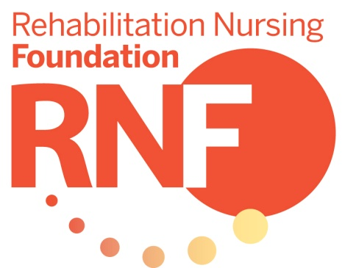

◻ Yes! I want to make a donation to RNF to support research that promotes excellence in rehabilitation nursing practice.

◻ $1,000 (Diamond level) ◻ $500 (Platinum level) ◻ $250 (Gold level) ◻ $150 (Silver level) ◻ $50 (Bronze level) ◻ other amount $_________

Name

Address

City State Zip

Payment
◻ Check payable to RNF ◻  Visa ◻  MasterCard ◻  American Express

Account number Expiration date

Signature Cardholder’s name (print)

Please mail completed form to:

Rehabilitation Nursing Foundation
1061 American Ln Suite 310
Schaumburg, IL 60173

Thank you for your donation!
Contributions to RNF may be deductible as a charitable contribution. Consult your tax adviser for more information.

