ARN NIWI Scholarship Application

Nurse in Washington Internship (NIWI)
Washington, DC
March 23-25, 2020

Application Deadline: January 10, 2020

ARN is committed to impacting healthcare as a leader in influencing rehabilitation public policy. As a part of this commitment we want to ensure that our members have the knowledge and opportunity to participate in the creation of public policy and advocacy related to rehabilitation nursing. In that spirit, we are pleased to announce the ARN NIWI Scholarship.

NIWI provides nurses with the opportunity to learn how to influence health care through the legislative and regulatory processes. Participants learn from health policy experts and government officials, network with other nurses, and visit members of Congress. For more information about NIWI, visit this link.

Each ARN NIWI Scholarship will cover registration, lodging, and travel expenses for one ARN member who meets the scholarship eligibility criteria. One scholarship will be available in 2020. The ARN Health Policy Committee will review all applications and select the applicants deemed most appropriate as the award recipients.

Eligible nurses will be:
- A registered professional nurse with current, unrestricted license;
- A current ARN member (minimum of one year membership);
- New to NIWI, not having attended in the past;
- Able to join the Health Policy Committee following a successful scholarship application;
- Currently practicing in the rehabilitation specialty;
- A good communicator, both in writing and orally.

To apply for the scholarship, please submit the following materials:
- A complete biographical data form and scholarship application (attached)
- Curriculum vitae

Your application must be emailed to Melissa Bellows at mbellows@rehabnurse.org. Applications must be received by January 10, 2020 to be considered.

If you have questions, please contact Melissa Bellows at mbellows@rehabnurse.org or 847.375.6356.

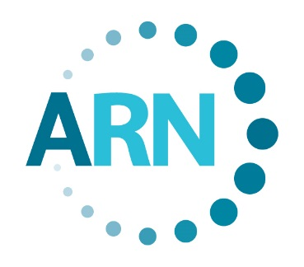 ARN NIWI Scholarship Application

Please complete this form to document adherence to ARN eligibility criteria. Please enter your information in the gray shaded areas of this form. Once complete, please email this application along with your CV to mbellows@rehabnurse.org. Please put an asterisk by your preferred mailing address.

Name: Credentials:
Home Address:
Place of Employment:
Business Address:
Business Telephone: Home Telephone:
E-mail Address:
U.S. Congressional Representatives
Senators:
Representative:
ARN Membership Number: Member Since:
Registered Nurse License Number: State:
Please list two professional references
Name: Phone:
Name: Phone:

Answers for the following questions should be limited to 150 words or less.

Please describe your present professional position.

Please describe any involvement you have had participating in ARN on a national or chapter level in the last three years.

Please describe any previous involvement you have had in public policy/advocacy related to rehabilitation nursing.

How will you use the knowledge gained from NIWI and apply it to your area of practice, ARN, and nursing as a profession?

Have you attended NIWI in the past?

Signature Date

All materials must be received no later than January 10, 2020

